ADDITIONAL INSTRUCTIONS AND INFORMATION

University of Iowa Research Foundation
Invention Disclosure Form

Thank you for disclosing your invention/technology to the University of Iowa Research Foundation (UIRF). The UIRF’s mission is to assist and support inventors at the University of Iowa commercialize their inventions and other innovations.

This disclosure form is the first step in a process that could potentially lead to commercialization of your invention/technology. Completion of this form is very important and assists UIRF in multiple ways:

- This form acts as a written, dated record of your invention/technology.
- It also provides the UIRF with the information needed to fulfill any obligations UI owes to the granting organization—federal, state, foundation, corporate—that funded the research leading to your innovation.
- It provides the UIRF with the basic information to assess the commercial prospects of your invention and plan an intellectual property strategy.

It is important that you provide a comprehensive and complete invention disclosure so that UIRF can make an informed decision on whether or not to move forward with your invention. Text fields will expand—if you run out of space, please attach a document with the rest of your information. If you have prepared documents that answer a particular question, you may reference those and attach copies. It will be very helpful if you can provide attachments in electronic form. Please complete this form to the best of your ability. Fully completed disclosures help expedite the process of understanding and properly evaluating your invention.

Upon receipt of the completed disclosure form, a UIRF licensing associate will be assigned and will contact you to arrange a meeting. The purpose of this meeting will be to acquaint you with UIRF's evaluation process, to gain a more comprehensive understanding of the invention/technology and to determine and define next steps. If you would like help completing this disclosure form, a UIRF licensing associate or disclosure manager would be happy to assist you; please contact them with your inquiry.

IDF Instructions

Below is a short glossary of terms that may clarify the IDF instructions and assist you in completing it. If you have more questions, please contact a member of the UIRF staff. Additional information is also available on the UIRF website at: https://uirf.research.uiowa.edu/

Starting the Form in Workflow

The UIRF’s online IDF is run through Workflow, and the online IDF will behave similarly to other packages routed through Workflow’s system.

To access the form:
- Log into Workflow by following this link - https://workflow.uiowa.edu/form/uirf-idf2
- Sign in with your HawkID and password. The form should appear.

If you have trouble with this, please contact the UIRF at 319-335-4546 or uirf@uiowa.edu.

Saving the Form
If you need to gather information to complete the form to submit at a later time:
- Check the "Form not final" checkbox at the bottom of the page
- Click the Submit IDF to UIRF button at the end of the form to save it
A
If you do not check this box and click submit, your progress will be lost.
- Receive email from Workflow, use link to return to the IDF in your Workflow inbox and edit. Make sure your Quick Views are set to “History: Complete Through Workflow” to view the form

Submitting the Form to the UIRF

If you need to edit the form, you must save it first (see Saving the Form instructions at the start of this document). Once you have completed the edits, uncheck the “Form not final” box and click the “Submit IDF to UIRF” button at the bottom of the form.

Once you have done so, the UIRF’s disclosure manager will be able to see your invention, route it to other UI inventors for signatures, and approve it.

If you errantly submit your invention to the UIRF before it is ready, please contact UIRF at 319-335-4546 or uirf@uiowa.edu.

ADDITIONAL INSTRUCTIONS AND INFORMATION

1. TITLE OF INVENTION
Create a short title describing the invention without revealing any specific details that would enable others to make and use it (that is, don’t give your key discovery away in the title).

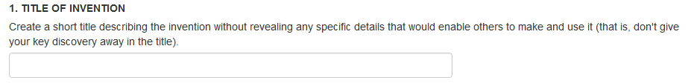

2. BRIEF SUMMARY OF THE INVENTION
In layman terms, please give a brief overview (200 words max) of the invention innovation itself. Include how it is to be used and/or why it is useful. Briefly describe what makes the invention innovation new and unique.

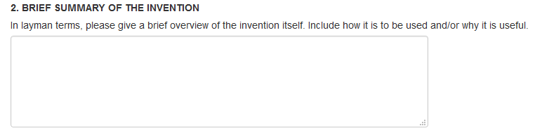

3. FUNDING SOURCES
Through contracts with the University, most sponsors may have obtained intellectual property rights and thus require notification when an invention or other intellectual property is created. It is important, therefore, that all external sources of funding used in the creation of the invention, including contributors’ salaries (e.g., NIH or NSF grants), be reported to this office. The University requires this information in order to comply with the terms of your grant awards. Recent Bayh-Dole changes require both the grant number and award date to be compliant.

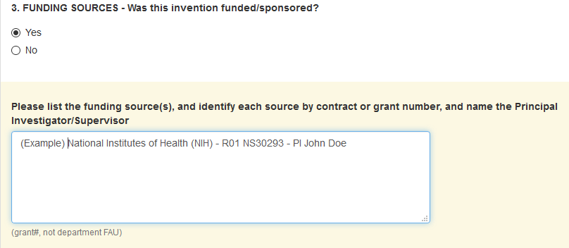

4. PUBLIC DISCLOSURE
Any of the following may be considered a public disclosure:

- Publication in a paper, or on the web
- Use of the invention in a public setting
- Written or oral presentations, such as at a conference, symposium or gathering; includes research posters
- Publication in a non-confidential federal grant proposal (when funded, it may become public)
- Non-federal funding proposals
- Thesis defense seminar
- Disclosure to a colleague at another institution, or to a collaborator at a private company, without a confidentiality agreement in place
- Distribution of tangible materials containing the invention without a confidentiality agreement
- Offer of the invention for sale

In the United States, the opportunity to obtain patent protection remains for one year after a public disclosure, use, or offer of sale. Outside the United States any public disclosure, use, or sale will immediately bar patent rights in most foreign countries.

Please include all past public disclosures and future planned public disclosures. Note that in some cases even the title of a publication alone may constitute a public disclosure if the title describes important aspects of the invention or enables someone with your skill and background to duplicate the invention without rigorous experimentation.

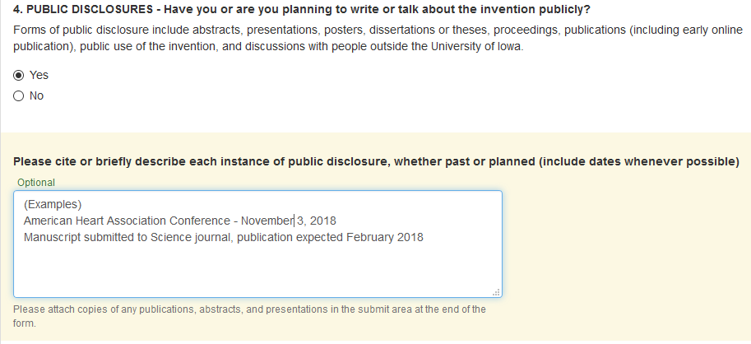

Please provide a copy of what you have presented or will be presenting. If you have a manuscript or abstract ready for submission describing the invention/creation, please forward a copy to us and identify the journal or conference where the manuscript will/did appear, including relevant dates. Be sure to include the dates and URL of any web publications, if you have them. Many times, abstracts and articles are posted to the web prior to the full online or print distribution.

It is very important that you inform us if you make plans for any additional public disclosures of this invention/creation after submitting this form

5. AGREEMENTS & PROPRIETARY (NON-UI-OWNED) MATERIALS
Proprietary and non-UI-owned materials may include items received as a gift or obtained with or without a written agreement. “Strings” or conditions of use may also have been discussed in e-mail exchanges. Please attach any relevant emails or other documents such as licenses or material transfer agreements. Examples include:

- advanced materials that may have been used as base materials or substrates for surface modification, coating, or chemical or physical alteration
- animals, plants, and viruses
- catalysts
- cell lines
- combinatorial chemical libraries
- DNA materials including gene libraries, vectors, plasmids, and other sequences
- enzymes, monoclonal antibodies, and other proteins
- eukaryotic and prokaryotic cultures (animal and plant cell lines, yeasts, bacteria, and other microorganisms)
- fluorophores, labels, or "tags"
- microarrays
- open source software
- plasmids
- purification methods
- reagents
- RNA materials including RNA libraries
- software development tools

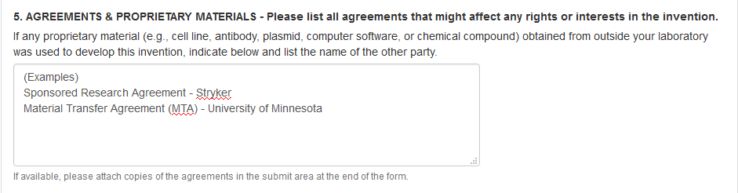

6. CONTRIBUTOR AFFILIATIONS

Invention contributors with affiliations and/or dual appointments with other institutions should report those affiliations to the UIRF. Affiliations should be reported even if the appointment is without compensation or the invention was not conceived or developed with the use of the other institution’s resources. The other institution may have obtained intellectual property rights to the invention and require notification when an invention is submitted to the UIRF. Examples of common contributor affiliations include VA or HHMI dual appointments. Please also include affiliations with startups or other companies as well.

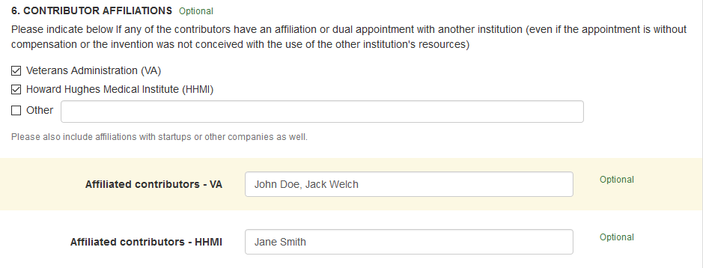

7. INDUSTRY PARTNERS/POTENTIAL LICENSEES
Invention contributors often provide leads to potential licensees, which can greatly expedite the licensing process. Please list industries and particular companies that may be interested in your invention or could potentially benefit from the use of this technology. If you have any specific contacts within relevant companies, please list them as well.

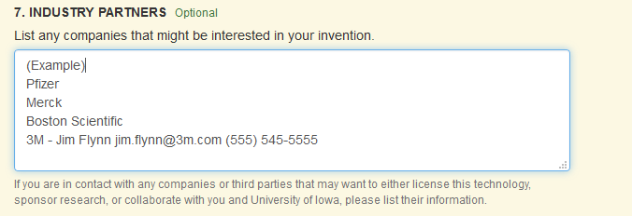

8. DETAILED DESCRIPTION OF THE INVENTION

Please describe the invention in as much detail as possible. The invention must be sufficiently complete in technical detail to convey a clear understanding to the extent known at the time of the disclosure, of the nature, purpose, operation, and physical, chemical, biological, or electrical characteristics of the invention.

Start with what is the unique and novel or “new” feature. Include details on how to actually make, assemble, synthesize, or build the invention and details on how it is used once it is made. Include data, drawings, figures, supporting literature, your thoughts and logic behind it. If the invention involves chemistry or biology, provide evidence that the process or compound exists and functions in the way you describe.

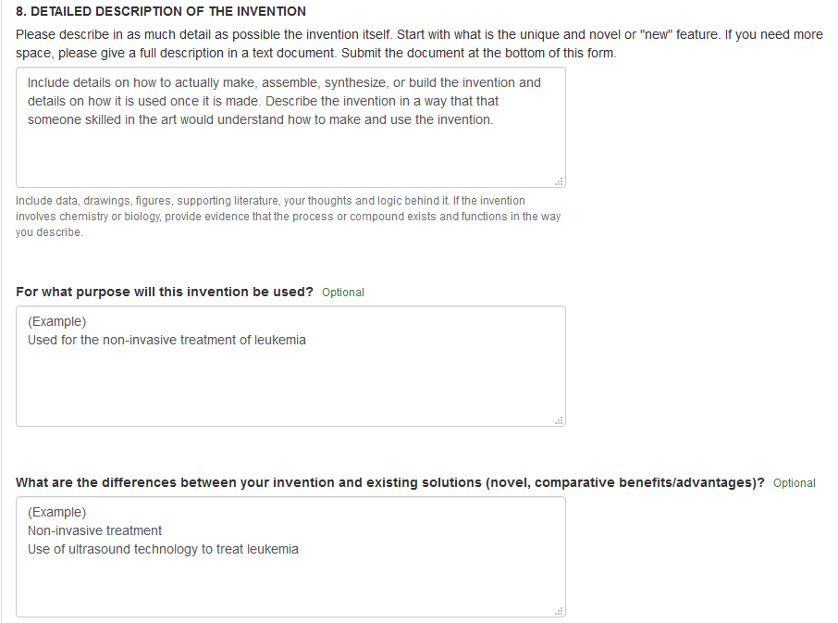

9. STAGE OF DEVELOPMENT OF THE INVENTION

Unless previously stated in the invention description, describe the stage of development of the invention (e.g., concept stage, experimental stage, computer model simulation stage, working prototype stage). Providing us with this information helps the UIRF determine a timeline for evaluating the invention, including what resources may be necessary to make the innovation ready for marketing and intellectual property protection. If available, please include data, photographs, etc., indicating the stage of development.

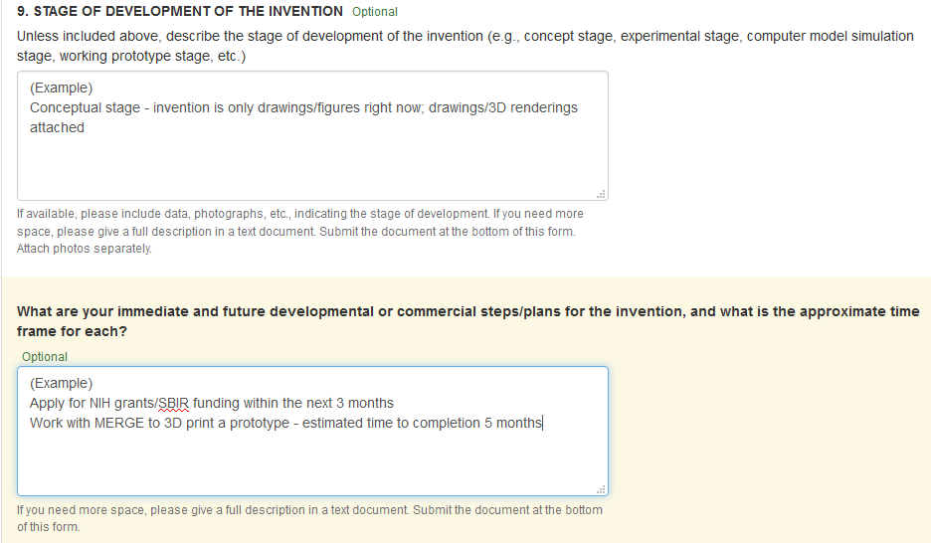

10. EXISTING SOLUTIONS & PRIOR ART
Existing solutions may sometimes be referred to as "prior art" and refer to the existing body of technical information (some of which may be identified in scholarly works through literary searches) against which an invention is judged to determine if it is patentable (novel, non-obvious, and useful). Prior art includes publications and patents or other written documents that describe the invention as well as oral presentations of the invention or its sale or use in public, again by you or by others. Listing potential search keywords that relate to your technology may help uncover prior art and allow the UIRF to better evaluate our ability to obtain a patent on your innovation.

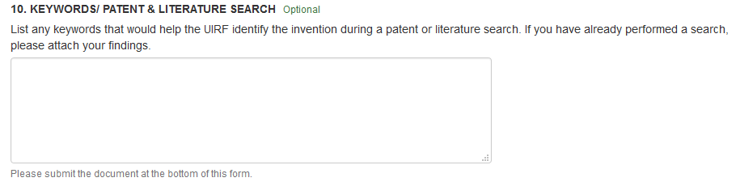

11. INVENTION CONTRIBUTOR DETAILS
If a faculty member, staff member, student, visiting scientist, or visiting scholar made his/her contribution to the invention while at UI (even if the person is no longer associated with UI), they are considered an UI Contributor. A current UI employee that made his/her contribution while employed elsewhere is NOT considered an UI Contributor and should list their organization during the time of their contribution.

Please be advised that contribution to an invention does not equal inventorship. Inventorship is a legal determination that will be made at the appropriate time(s) by a patent attorney. Individuals who solely provided funding, research materials, equipment, assistance in routine statistical analyses, assistance in routine testing, access to standard protocols, or individuals who bring to one’s attention the existence of a problem but not the solution are not inventors.

Although there is no legal significance to the order of names on a patent application or an issued patent, you may consult with the others who are likely to be inventors, and submit their names in the order you would prefer them to appear on a patent application, if one is filed. The UIRF cannot guarantee that the order presented in the IDF will result in an application or patent with names in the order originally presented.

For UI contributors
Simply list their name in the box provided and click “Search.” Then, select the correct profile that pops up. If you want to change the person, click the “Change Person” box that appears after a person is selected. The first person listed will be designated the “lead” contributor, UIRF’s primary point of contact for the invention.

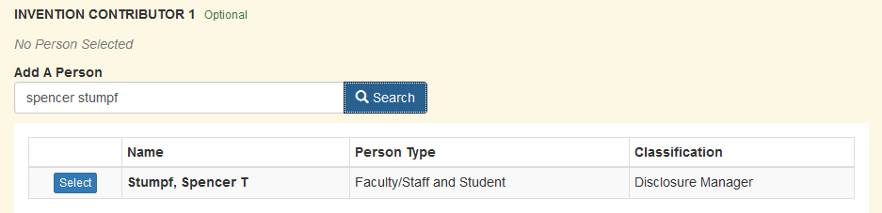

Contributor College/Department/Center Designations
Effective January 1st, 2019 in accordance with changes to the University of Iowa Intellectual Property (IP) Policy, invention contributors may now identify which of their affiliated departments/colleges/labs/centers/etc. contributed to the creation of the invention and subsequently should receive a share of revenue generated from the commercialization of the invention (in accordance with UI IP distribution policy). Invention contributors may designate more than one department or center and split between them. The UIRF will notify the identified departments/colleges/labs/centers/etc. of the inventor’s selection. This selection will occur after submission of the online invention disclosure form.

For non-UI contributors
Please list all non-UI contributors in the designated box below UI contributors. Include the person’s name, institution/employer, and contact information.

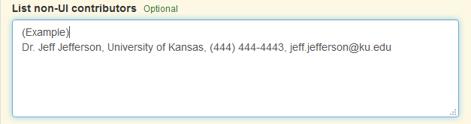

CONTRIBUTOR SIGNATURES

Certify that checking the box below and typing my name I certify that the information submitted is true, complete, and accurate to the best of your knowledge. Once officially submitted to the UIRF, the Disclosure Manager will review and forward the disclosure in Workflow to the other listed UI contributors for their signature as well.

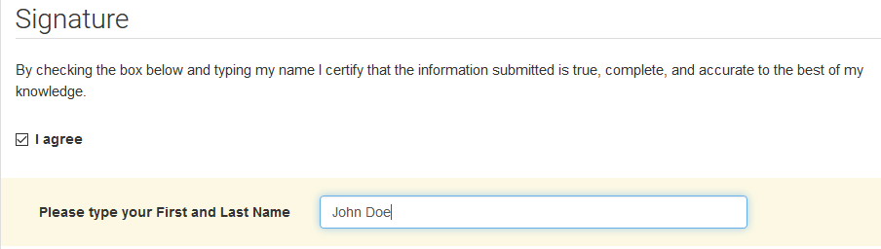

UPLOADING ATTACHMENTS

Browse for files or drag them over the Browse button next to “File”. Once the attachment shows up, choose an Attachment Type and give it a short Description. Once those are completed, click Upload File to attach it.

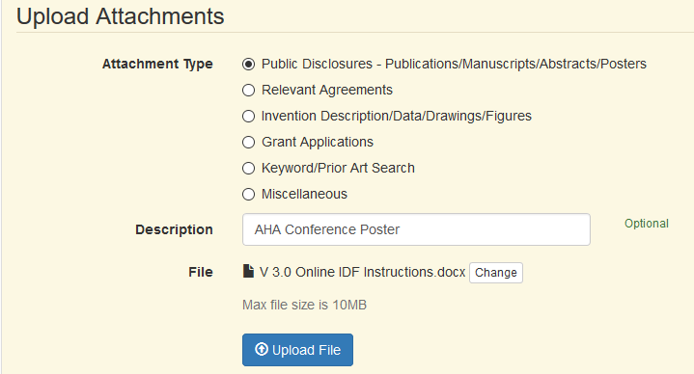
A longer glossary and additional information can be found under the under the Researcher FAQs and Definitions and Terminology pages on the UIRF website: https://uirf.research.uiowa.edu/

